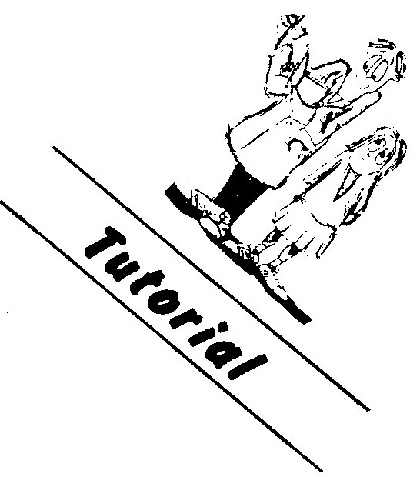
Physics
Nuclear binding energy

Atomic nuclei are made up of the basic building blocks, protons and neutrons. These are held together by nuclear binding energy. To illustrate this consider the helium nucleus. It consists of two protons and two neutrons. One would expect that if the mass of two protons was added to the mass of two neutrons the resultant would be that of a helium nucleus. This is not so. The difference in mass is linked to the binding energy by Einstein’s famous equation

E = mc²

Where E is the energy in J
m is the mass in kg
c is the velocity of light in ms⁻¹ (3.00 x 10⁸ ms⁻¹)

The binding energy per nucleon is found by calculating the total binding energy and dividing by the number of nucleons in the nucleus.
Masses can be expressed in terms of the atomic mass unit (u). this is defined as follows.

1u = 1.6605 x 10⁻²⁷ kg
1eV = 1.60 x 10⁻¹⁹ J
1MeV = 1.60 x 10⁻¹³ J
1u = 931 MeV

Example
Calculate the binding energy and the binding energy per nucleon of a lithium-7 nucleus, 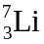.

mass defect = mass of component neutrons and protons - mass of nucleus

mass defect. for = {m( 3 protons + 4 neutrons)} - m()}

= 3 x 1.00728 + 4 x 1.00867 - 7.01436

= 0.04216 u

= 0.04216 x 1.6606 x 10-27 kg

= 7.001 x 10-29 kg

Binding energy = mc2

= 7.001 x 10-29 x (3.00 x 108)2

= 6.301 x 10-12 J

Binding energy per nucleon = 6.301 x 10-12 / 7

= 9.00 x 10-13 J

Problems
1. Of the two hydrogen isotopes, deuterium, 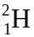, and tritium, 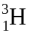, which has the highest binding energy per nucleon?

2. A small proportion of all the carbon in living organisms is the radioactive isotope carbon-14. Calculate the binding energy per nucleon of both the carbon-12 and carbon-14 nuclei and state which one is the most stable. The atomic number of carbon is 6

3. One of the simplest fusion reactions is
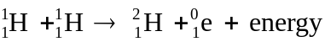

a. What mass does a single fusion reaction convert to energy?

b. What energy does a single fusion reaction release?

4. Uranium-238 undergoes a series of radiocative decays, the first of which is:
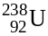 → 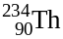 + 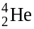 + energy
How much energy does each decay release?

5. Hydrogen and deuterium fuse to give the isotope 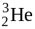.

a. How much energy does a single fusion release?

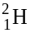 + 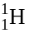 →

b. How much energy does a kilogram of reactant release?

6. Under certain circumstances, a gamma ray photon may suddenly change into an electron and a positron.
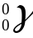 → 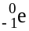 + 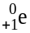

Calculate the minimum energy of the photon.

7. When 3.0000 MeV alpha particles bombard nitrogen 14, oxygen-17 forms and the reaction releases a proton. Calculate the energy this reaction releases.

 

